Task 4

Automate Assignment below task using github action.

1. Build Docker Image
2. Push Docker Image to Docker hub.

Create git repository

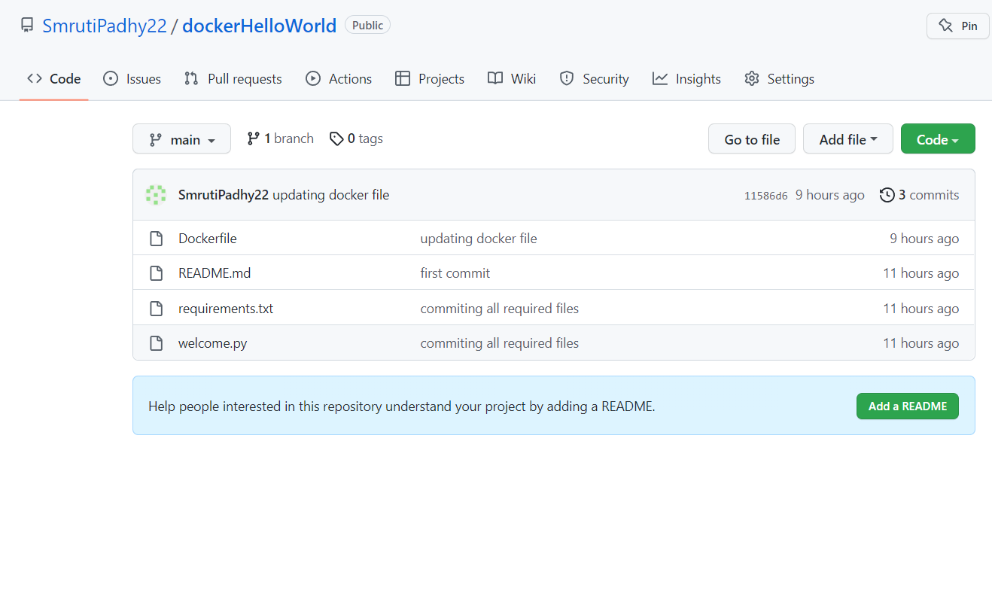

Go to Actions tab in git and select docker image config

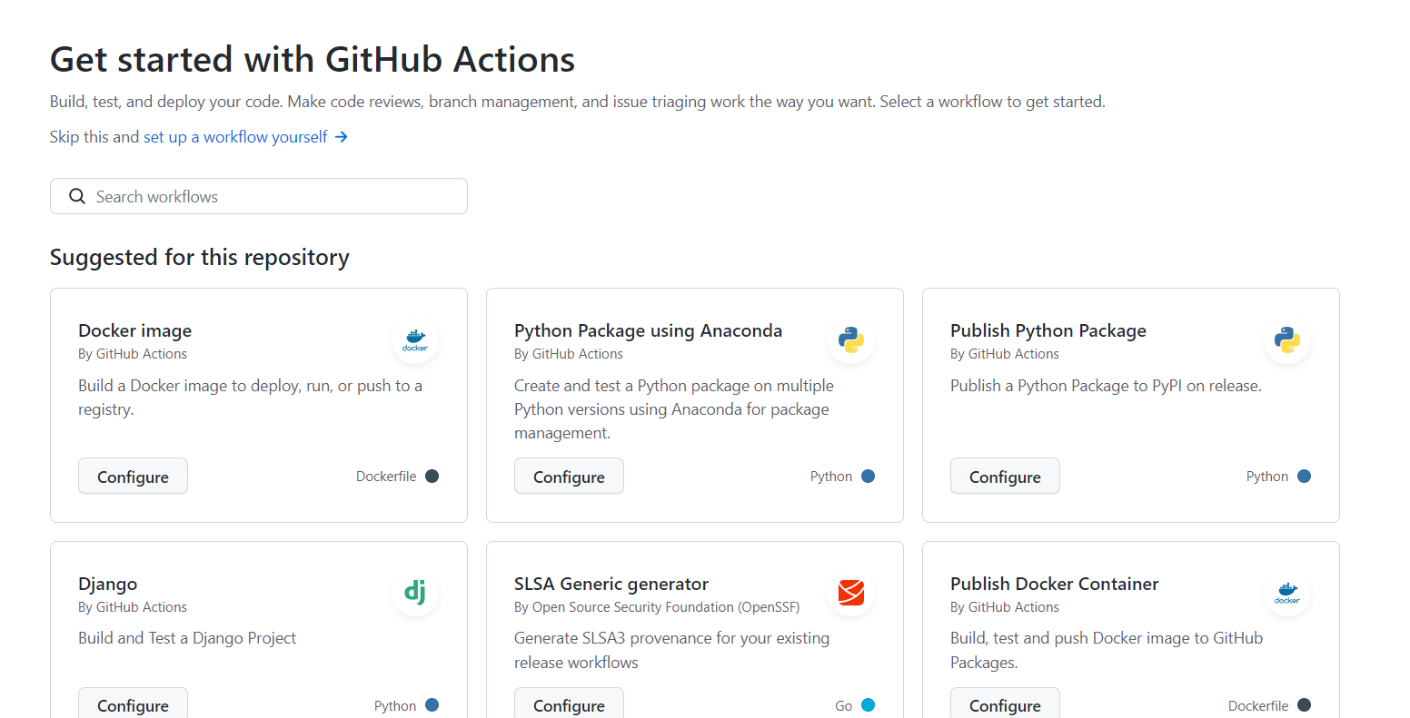

Create docker image yml file and commit to git

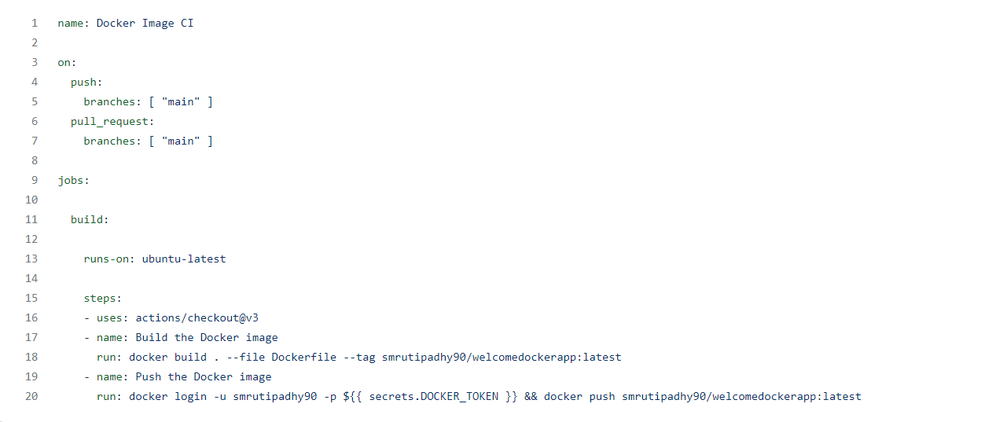

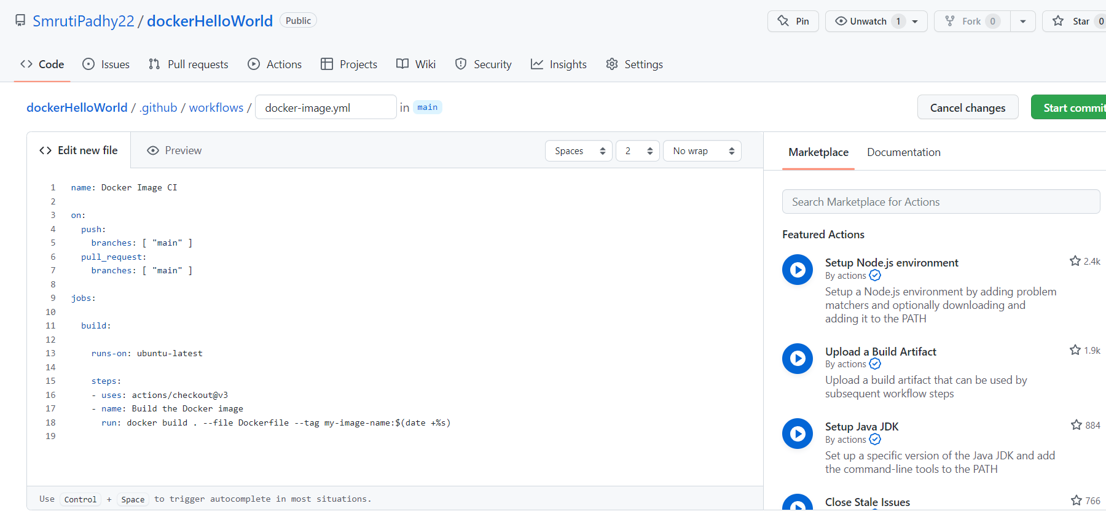

Now secret access token required for docker login. We can create from docker hub. \*Don’t share with anyone. Copy the token.

DockerHub > Account settings > Security > create access token

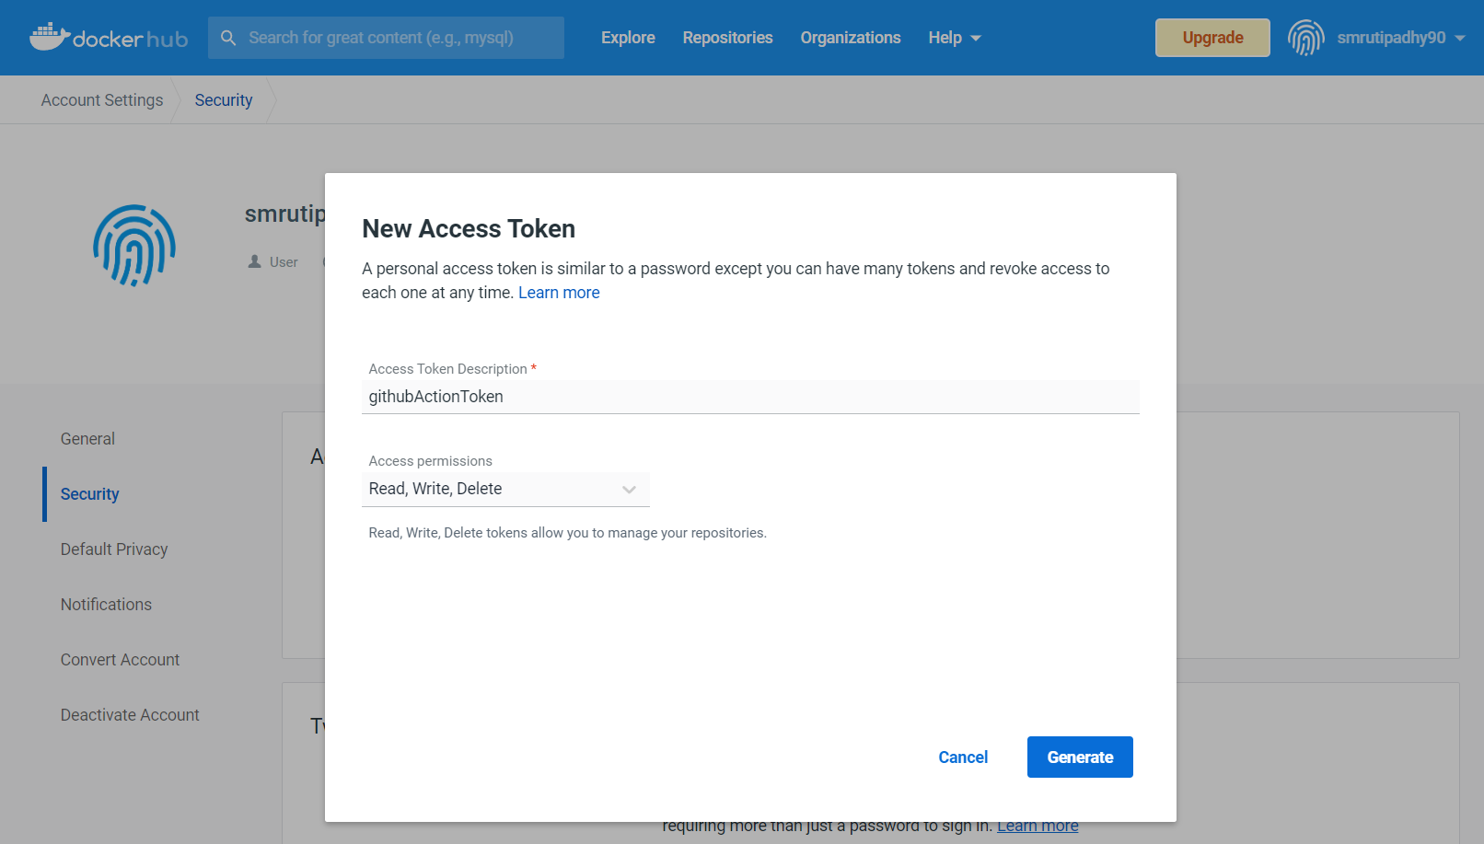

Create Secret Action Token in git. Copy the docker hub token and add as secret action.

Git repo > settings > Secrets > Actions

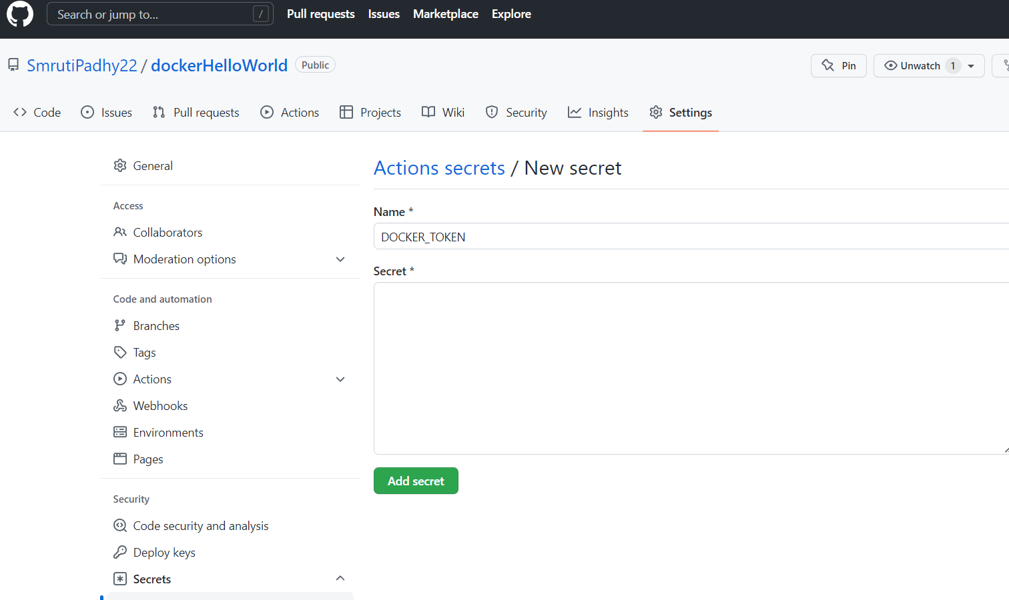

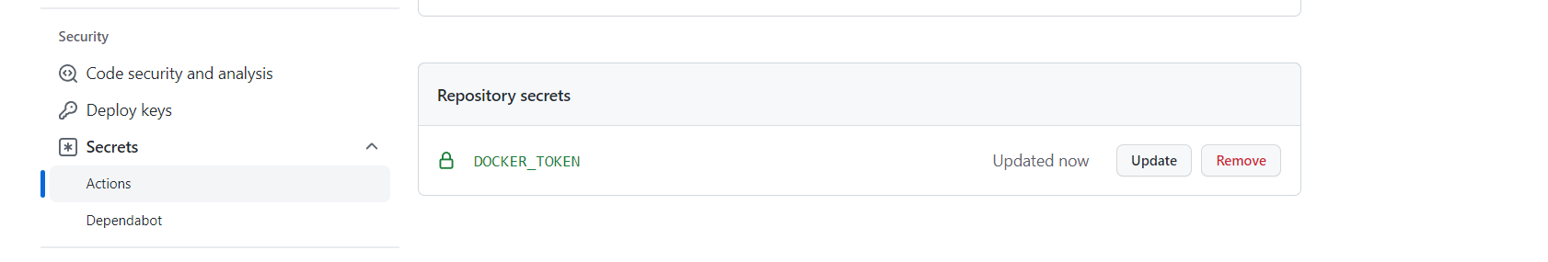

Add Access token code in yml file



Commit some code changes and push to main branch

